23045834

UFCFFV-15-M

Advanced AI, Computer Vision and Cybersecurity

PORTFOLIO

01ST OF MAY 2024

There is an increasing concern of skin cancer in the world today with about 1.5 million cases in 2022, skin malignancies are the most common type of tumors diagnosed globally. An estimated 330 000 new instances of melanoma were reported globally in 2022, and the disease claimed the lives of over 60 000 people. The incidence rates of melanoma vary greatly between nations and regions of the world. Understanding the different groups of skin cancers, early detection and treatment is crucial in combating this problem.

Differentiating between cancer and noncancerous melanoma skin pictures has drawn a lot of investigation since melanoma has a greater death rate than non-melanoma skin cancer. Though it has a lower death rate than melanoma skin cancer, non-melanoma skin cancer is the most common type among people with light skin, and this has significantly impaired the quality of life and health care services. Machine learning-powered automated diagnosis systems can improve patient care and outcomes by lowering practitioner variability, increasing diagnostic accuracy, and enabling prompt treatments.

For the effectiveness of our model in carrying out this work, it was important to get a dataset that was well versed in the various classes of skin lesions. This was important to ensure that overfitting or underfitting was avoided as much as possible and to make sure the model generalizes well to unseen data. It was with this in mind that the ISIC 2019 dataset was used for this purpose. This dataset contains 25,331 images with nine diagnostic classes; **Melanoma, Melanocytic nevus, Basal cell carcinoma, Actinic keratosis, Benign keratosis (solar lentigo / seborrheic keratosis / lichen planus-like keratosis), Dermatofibroma, Vascular lesion, Squamous cell carcinoma, None of the above.** Ethical considerations of the dataset were taken into consideration ensuring all ethical laws was being followed

After data acquisition, data preprocessing was done. Normalizing the pixel values of the dataset to a standard range of 0 and 1 was performed before model training. Converting the image data to float32 was also a necessary step to be done in this data preprocessing step. Performing one-hot encoding, converting class labels to numerical values using class mapping was crucial before the model can be trained.

Another step in the data preprocessing step is ensuring that images to be trained are free from noise but this was not carried out after observing images from the different classes of skin lesions was free from noise.

The data partitioning method taken at first for this project was using the train-test-split function from scikit-learn, but it was quickly observed during model training the importance of a validation data partition. Hence you would notice that in the model training process, a validation split 0.2 via the validation_split parameter in model.fit was included.

Models use features to create predictions, and through the process of feature engineering, new features can be derived from preexisting features. Using their knowledge of the problem domain, subject-matter experts manually develop human-engineered features. Analyzing representative datasets of pigmented skin lesions to identify visual cues and patterns that differentiate between benign and malignant lesions, with special attention to features like asymmetry, border irregularity, color variation, and lesion diameter, will help determine the human-engineered features. Relevant literature and clinical guidelines in dermatology will also be considered.

On this project, though, a different strategy was used. Convolutional Neural Networks (CNNs) were used in an automated manner to engineer features rather than by hand. CNNs are a kind of deep learning model that can be trained to automatically extract pertinent characteristics from picture data without explicit human assistance. Their ability to automatically construct hierarchical representations of visual features from pixel-level input makes them ideal for applications such as diagnostic picture analysis of skin lesions. This is a breakdown of what was involved;

Convolutional Layers: Adding two 32-filter Conv2D layers that run on 3x3 kernels shows how to extract spatial characteristics from input photos. To identify patterns and characteristics like edges, textures, and forms in the input image, these convolutional layers convolve filters over the image.

Pooling Layer: The feature maps derived from the convolutional layers are downsampled by adding a MaxPooling2D layer. By lowering the spatial dimensions and extracting the most notable characteristics, this pooling technique improves translation invariance and computing efficiency.

Dropout Layers: By arbitrarily deactivating a portion of neurons during training, Dropout layers—which come after convolutional and fully connected layers—help prevent overfitting. By using this regularization strategy, the network is better able to extract relevant information from the data by learning robust and generalizable features.

Layer of Flattening: Adding a layer of Flattening makes the feature mappings into a vector in one dimension, which makes the switch from convolutional to fully connected layers easier. The retrieved features are now ready for additional processing and categorization thanks to this transformation.

Fully Connected Layers: Two Dense layers add non-linearity and make it possible to discover intricate connections between the goal labels and the retrieved features. The output layer creates class probabilities, or how likely it is that each class will be given the extracted features, using the softmax activation function.

Synopsis of the Model: A brief synopsis of the model architecture is given via the model.summary() function call, which also includes information on each layer's type and output shape as well as the total number of trainable parameters. This synopsis provides concrete proof of the feature extraction model's application.

Convolutional Neural Networks (CNN) and Dense Neural Networks are two potent machine learning models used in this skin lesion classification study. These models were chosen for the task at hand due to their applicability and shown efficacy in handling picture data. The CNN model was designed to process and evaluate skin lesion images in an effective manner by stacking layers of convolutional, pooling, flattening, and fully connected layers. This allowed for correct classification in the end.

Using TensorFlow/Keras, the DNN model was implemented in a different way. It had no pooling or convolutional layers and was made up of layers that were closely coupled. This architecture worked with flattened input images and was less complex than CNNs. It attempted to learn informative representations from the data even though it did not directly use the retrieved features from the CNN model. With the help of the flattened input representation, the DNN model was trained to improve the features and generate predictions. To minimize loss and maximize accuracy, both models were trained using suitable loss functions (categorical crossentropy) and optimizers (Adam). To enhance performance, the model parameters were updated, and batches of training data were iterated over during the training process. To keep an eye on performance and avoid overfitting, the models were assessed using validation data.

The accuracy of the CNN model was 52.04%, and its precision and recall scores matched. In the meantime, the precision and recall scores of the DNN model yielded an accuracy of 37.68%. These performance indicators direct future iterations and optimization attempts by offering insights into how well each model classifies skin lesions.

The validation method that was used was using the validation split parameter of the model’s fit function for both models

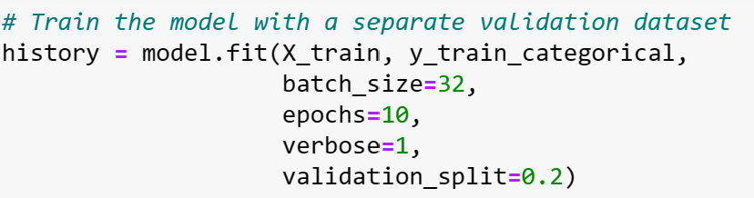

The images i,ii,iii and iv show the result of the CNN model used with epochs of 10

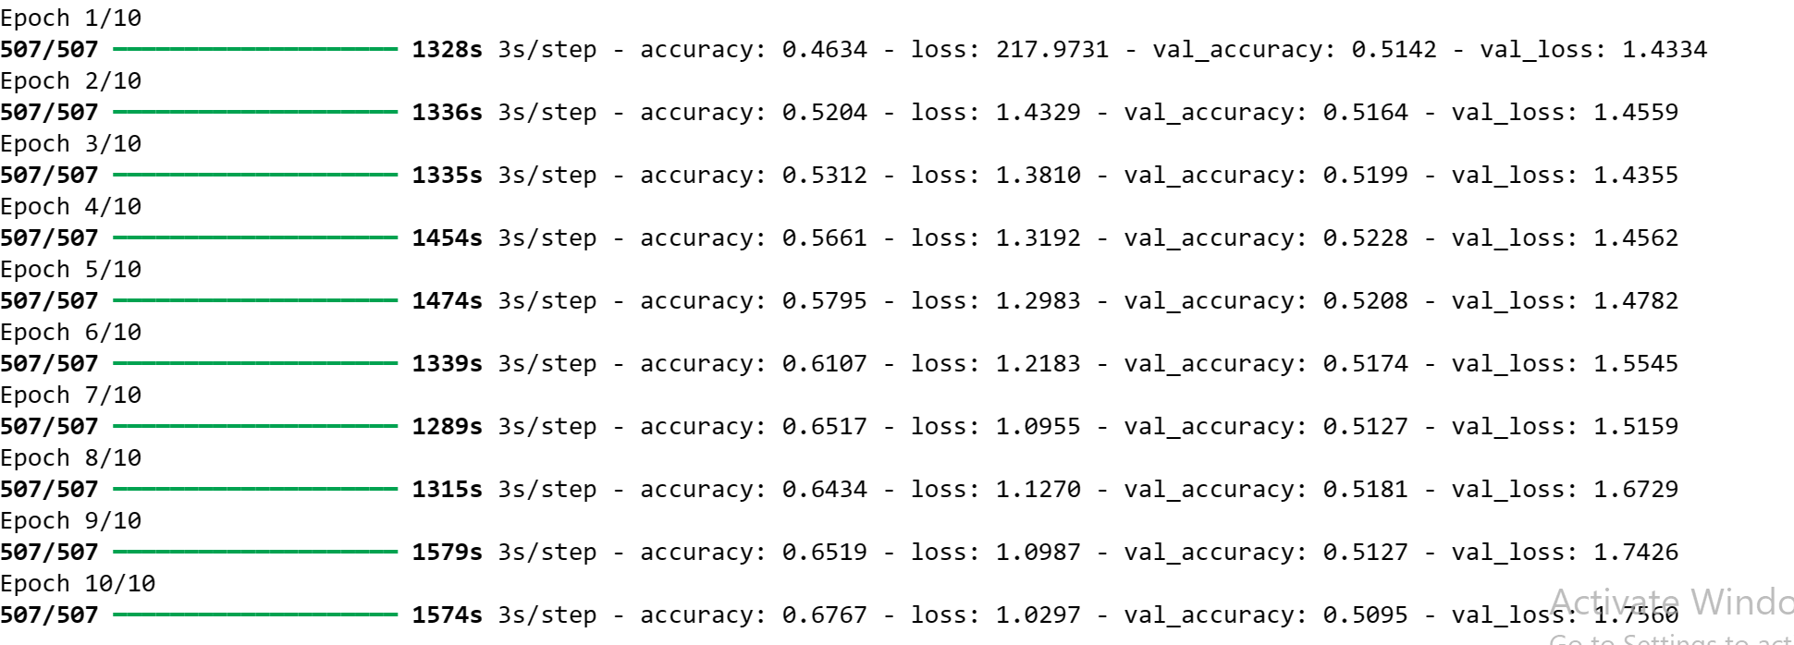Figure i and ii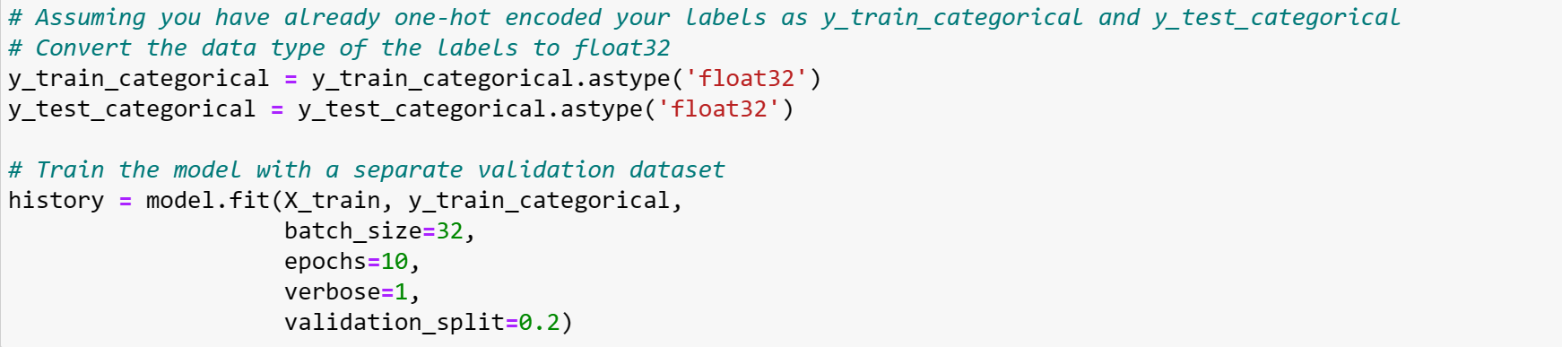

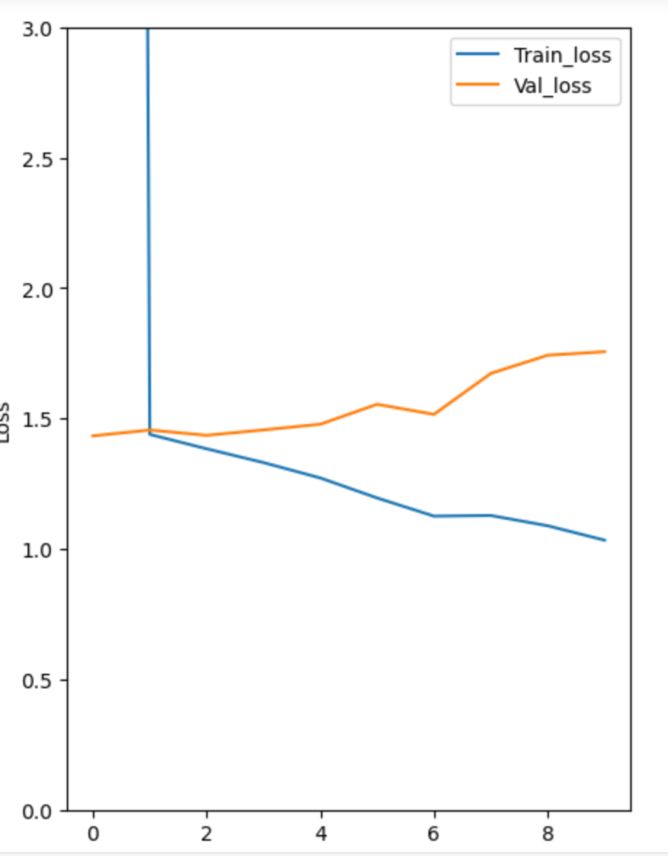

Figure iii and iv 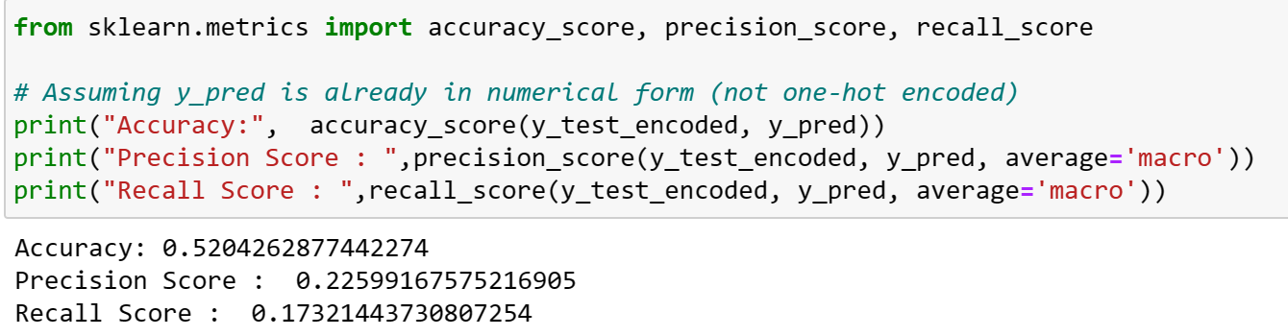

The figure iv and v above are the result of the DNN model carried out on 10 epochs.

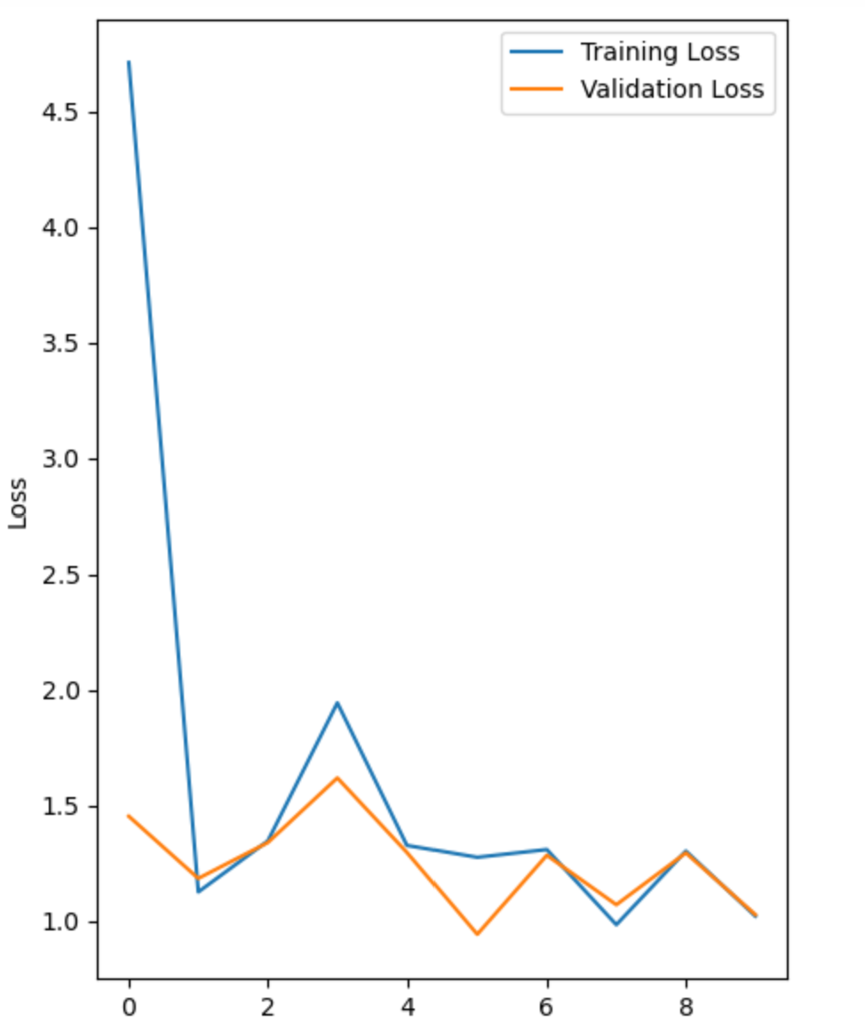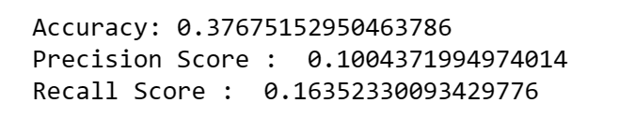

The CNN and DNN models were run on 30 epochs to understand the potential differences.

The figure vi and vii below show the results of the DNN model ran on 30 epochs

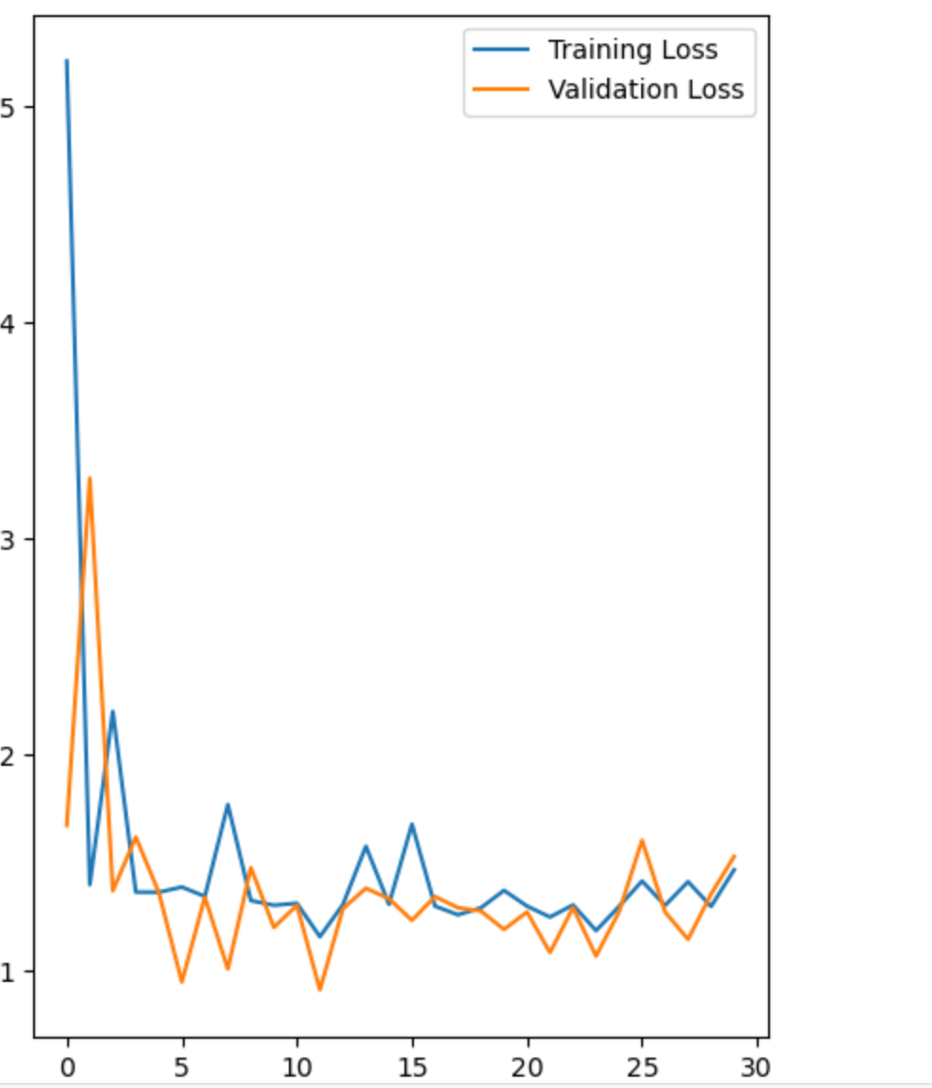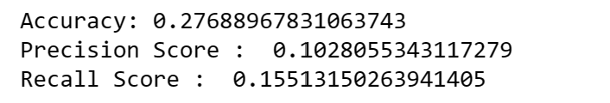

The figure viii and ix below show the results of the CNN model ran on 30 epochs

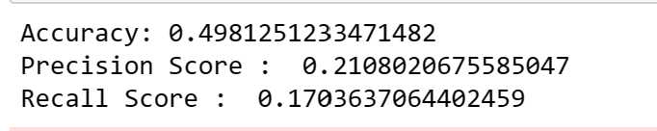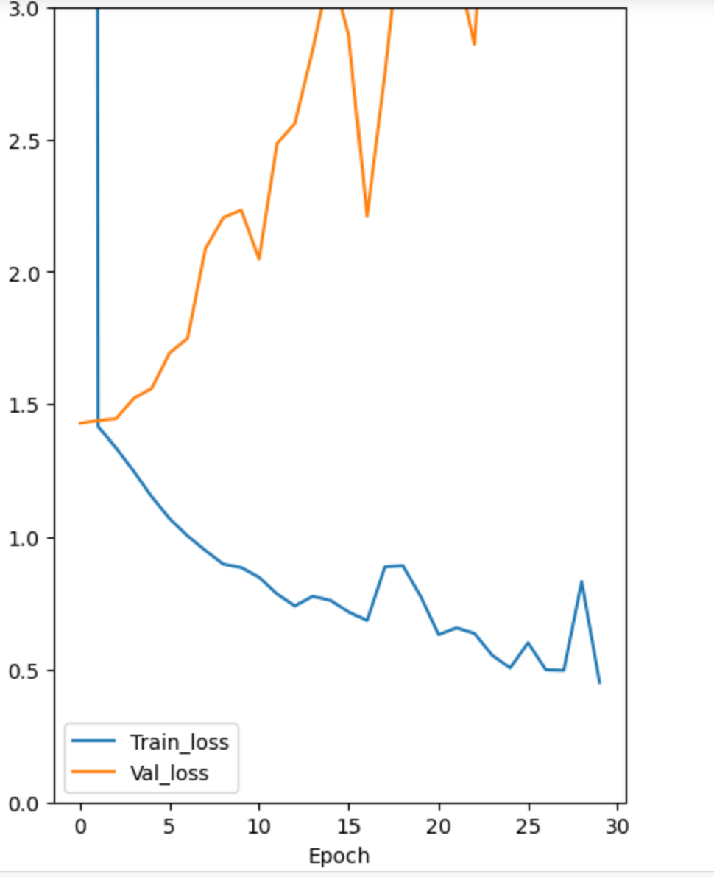

From all the images, the CNN model seemed to have performed better than the DNN model in the accuracy of the models. The DNN model had a lower validation loss than that of the CNN model and to better understand what could have resulted in this, a slight change to the CNN model was performed, reducing the number of neurons in a dense layer from 125 to 100 to control the model's complexity and potentially reducing overfitting. The figures below show the result of this attempt and from the results, the model struggles to maintain the same level of performance on the validation set, while achieving high training accuracy, suggesting that overfitting may have occurred. A few approaches can be investigated to resolve this problem and enhance the model's generalization performance: To stop the model from learning noise in the training set, additional regularization strategies like dropout, L2 regularization, or early stopping might be used. Hyperparameter adjustment can be used to maximize the convergence and generalization capacity of the model by modifying learning rates, batch sizes, or optimizer selections. 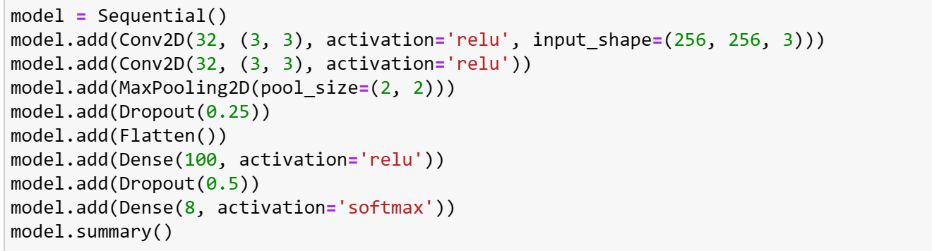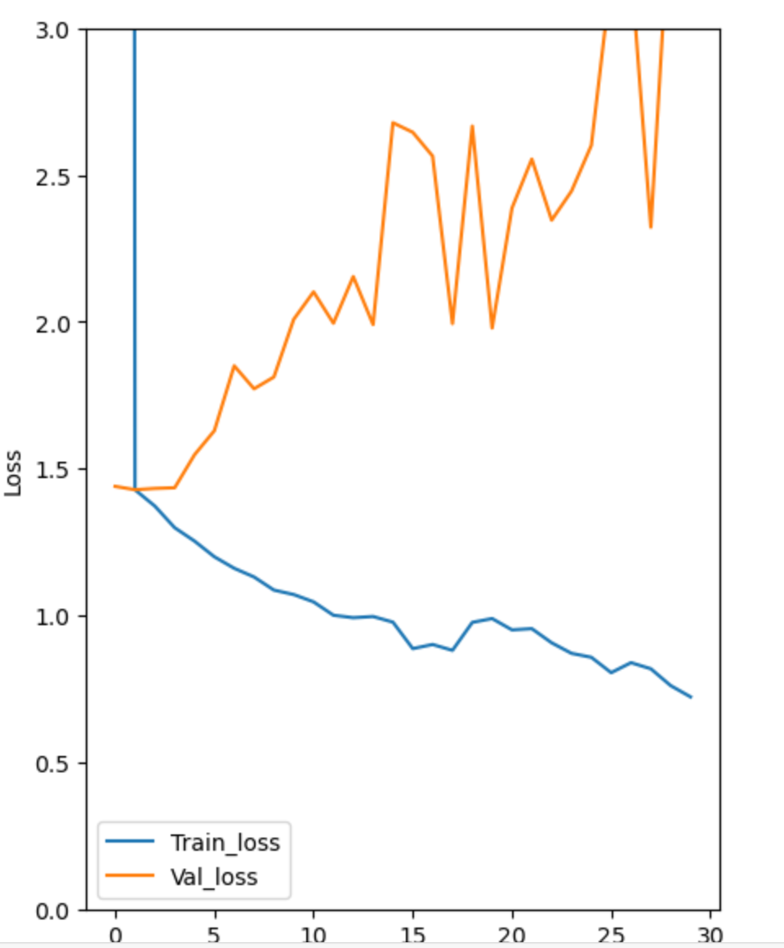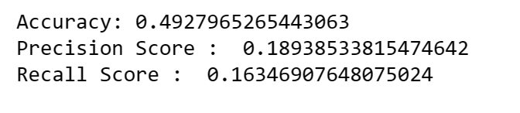

When considering cybersecurity, it becomes critical to acknowledge how constantly changing the world of digital threats and vulnerabilities is. To effectively build defenses and manage dangers, several critical areas require attention. Regarding this project, the potential issues to be wary about are; Data privacy and protection, model threats like model poisoning, and Data integrity. Having an appropriate measure system to avoid this was paramount in the success of this project.

References

J. Kawahara, A. BenTaieb and G. Hamarneh, "Deep features to classify skin lesions," 2016 IEEE 13th International Symposium on Biomedical Imaging (ISBI), Prague, Czech Republic, 2016, pp. 1397-1400, doi: 10.1109/ISBI.2016.7493528. keywords: {Feature extraction;Lesions;Skin;Malignant tumors;Image segmentation;Skin cancer},

*Working under the sun causes 1 in 3 deaths from non-melanoma skin cancer, say WHO and ILO*. (n.d.).<https://www.iarc.who.int/cancer-type/skin-cancer/#:~:text=Introduction&text=Skin%20cancers%20are%20the%20most,people%20died%20from%20the%20disease>.